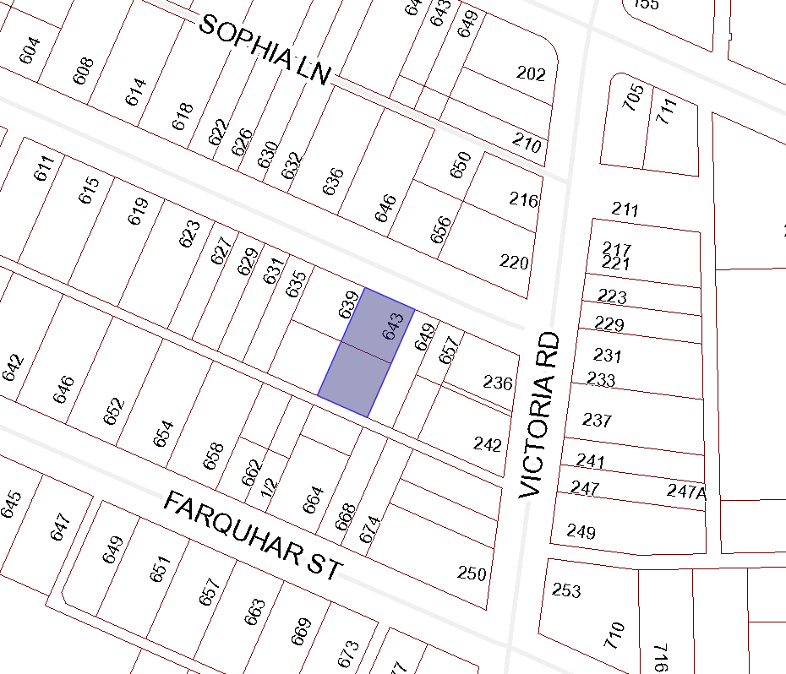

BOARD OF VARIANCE APPLICATION BOV00661

LOCATION MAP

CIVIC: 643 Kennedy Street

LEGAL: SECTION D, OF LOT 3, BLOCK U, SECTION 1, NANAIMO DISTRICT, PLAN 584

